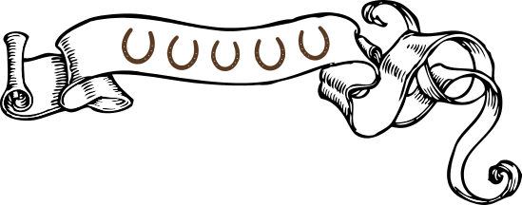

Menu

**To Start**

Today’s soup £6.50

Home-made bread

Duck liver parfait, medlar jelly, £7.00

toast

Confit guinea fowl spring roll £7.00

Celeriac and apple slaw, plum sauce

Twice baked cheese soufflé £7.00

waldorf salad with walnuts and chicory

Homemade charcuterie board, £8.50

fennel salami, chorizo, coppa ham,

sauerkraut, pickles

Cormish mussels “mariniere” £7.50/ 14.00

Home-made bread

Crayfish and smoked salmon open sandwich £11.50 rocket, lemon & paprika mayonnaise

______________________

Side Orders all £4.00

Side salad, chips, new potatoes,

Seasonal vegetables, Spiced red cabbage,

Home-made bread platter with olives, roasted garlic and butter

_____________________________________

_

Main

Fillet of bream

fregula puttanesca, rocket, red onion £17.00

Cauliflower and truffle lasagna £14.50

tenderstem broccoli (vg)

Roast haunch of venison £20.50

fondant potato, red cabbage, cauliflower puree,

beef dripping roasted carrots

Braised short rib of beef £17.50

Confit garlic mash, red cabbage, broccoli

Aubergine and puy lentil moussaka £15.00

Chicory and red onion salad (vegan)

Our steaks are 30 day dry aged, local beef

8oz Rib eye steak £23.50

watercress salad, chips, garlic & parsley butter

10oz Flat iron steak £18.00

plum tomato, chips, peppercorn sauce

Pub classics

Beer battered haddock fillet, £14.50

chips, crushed peas, tartar sauce

Venison and beef burger £13.50

caramelised onions, cheese, dill pickles

salad, chips

Falafel burger £13.50

Red pepper, carrot & fennel slaw, chips

Kids pasta, (tomato sauce) £6.50

Reuben sandwich £11.50

Our own toasted granary, sauerkraut,

pastrami, gruyere cheese, chips

(lunchtime only)

A discretionary 10% service will be added to the final bill for tables of 8 or more ___________________________

Food allergen information is available on request. Please ask your server

Puddings

Apple and cinnamon crumble £6.50

vanilla custard

(vegan version available)

Rhubarb and ginger cheesecake £7.50

Steamed ginger pudding £6.50

Vanilla custard

Chocolate, peanut butter brownie (GF) £7.00

vanilla ice cream, roasted peanuts

Lemon trifle £6.50

Affogato…… £4.00

(vanilla ice cream with

a double espresso)

Cheese board £9.50

selection of local cheeses,

warm bara-brith, chutney

